5.Insert a new row into the *Facility* table with facility name “Swimming Pool”.

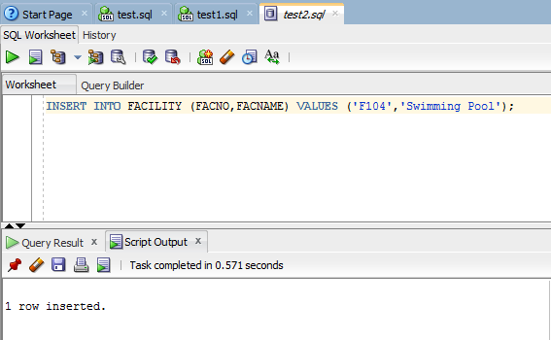

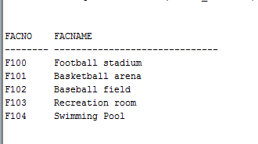

INSERT INTO FACILITY (FACNO,FACNAME) VALUES ('F104','Swimming Pool');